Thin Film Coater TFC200-400

The smart way to start your upscaling research

Features
- Print functional films with nanometer precision
- Small size (only 200x300x125mm³), large deposition area (150x150mm² for doctor blading and approximately 80x150mm² for slot-die coating)
- Ideal for saving precious lab space with minimized heat dissipation, especially important in glovebox environments
- Free positioning of control units for motion and temperature
- Features:
  - 1-100 mm/s
  - Up to 120°C hotplate temperature
  - Adjustable applicators

See also

Consumables

Size and Hotplate Options
Art. No. | Description
TFC200 | Film appicator small 200×300 mm²
TFC300 | Film applicator middle 300×400 mm²
TFC400 | Film applicator large 400×500 mm²
TFCXXXH | With hot plate
TFCXXXVH | With vacuum hot plate and vacuum pump

Adjustable Doctor Blades
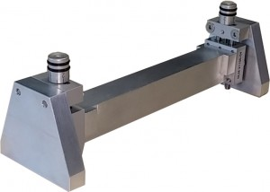
Universal Applicator for doctor blading with adjustable height from 0-11 mm to suit a large range of substrates.
Art. No. | Description
DB200 | Small – length 200mm
DB300 | Large – length 300mm

Slot-Die Applicators and Coating Heads
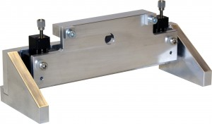

Key Features
- Transform a film applicator into a slot-die printer
- Height adjustment over more than 6 mm
- As bundle with slot-die head, syringe pump, pipe heaters and consumables starter kit or customized to hold your choice of slot-die heads
- Optional computer-controlled system with film applicator and syringe pump for highest reproducability
Art. No. | Description
CS100 | Control system for the whole slot die coating process with software and PC
SA80 | Slot die applicator for 80mm coating head
SC80 | Coating head 80mm
SH80 | Heating system for coating head 80mm incl. ink and pipe heater – 4 temperature controllers for individual heating
SA150 | Slot die applicator for 150mm coating head
SC150 | Coating head 150mm
SH150 | Heating system for coatig head 150mm incl. ink and pipe jeater – 4 temperature controllers for individual heating
SP10 | Syringe pump for up to 10ml syringes
SP20 | Syringe pump for up to 20ml syringes

